Summary of WESyS Project from FY17 through FY19 (October 2016 through September 2019)

Paper topic options

FY19 Q3 milestone review + Q4 kickoff

* **Question 1: How much more “learning” is needed to get HTL to take off?**
  + **How much installed capacity do we need to implement to have HTL take off (e.g., 3 plants vs. 10 plants)?** – *Plants of what size you want/ location?*
* **Question 2: How do dynamic tipping fees change the outlook for HTL?** 
  + **What’s the tipping point? How high do tipping fees need to be to incentivize incineration of sludge?**
* Question 3: How do air pollutant emissions change under different WTE scenarios?
  + Study in CA to understand AQ permitting issues and impose hurdle cost for meeting compliance
* **Question 4 (or connection to Question 1): How do maturity multipliers influence HTL takeoff?** 
  + **Monte Carlo study to explore maturity multipliers for HTL**
* Question 5: When do credits matter?
  + Explore non-intuitive finding — impact of credits (not as much of a driver as one might have thought)
  + Perform one-at-a-time sensitivity to assess LCFS and RIN impact
  + Also explore PNG FCI incentive
  + Does how you spread out the money (5 M over 5 years vs 25 million outright) matter?
  + How much does it change output?
  + Develop as white paper or presentation (internal only)
* Question 6: blending
  + If suddenly increased influx by 20%, what impact would that have?
* Question 7: **how does changing the $/barrel price impact HTL takeoff?**
  + At what crude price does this start to get interesting?
  + What would happen with an asymmetric price curve?
  + Prolonged high price with crash, etc.
  + How long would it need to be at that high price?
  + Diesel vs crude
  + Where do you get the value from – look at what the value
  + Contextualize changes within fuel value
* Example research questions that could be answered by possible extensions of WESyS
  + How would a renewable gas standard impact the market potential of different WTE pathways?
  + **What are the leverage points for hybrid WTE technologies? -** *it is not a multiple investment question?*
  + How many jobs could be created by the WTE industry? Where might they occur?
  + How does the price of land application of wastes impact how waste is used?
  + What are the environmental impacts of the WTE industry? How to they evolve over time and how might they change under different policy scenarios? – *Would you like to do emissions estimation or something?*
  + How might the growth of the WTE industry impact attainment zones for criteria air pollutants?
* Example research questions that could be answered by the current version of WESyS
  + How would the addition of new technology pathways in the LCFS impact energy production from waste? – *basically you want to turn on this path in other modules and see?*
  + How much would the LCFS credit price need to be to incentivize greater investment in WTE technologies? -
  + How does the market potential of WTE pathways change if RIN and LCFS credits go to zero in 2022 and 2020, respectively?
  + How do landfill diversion requirements impact the WTE industry? - *what is the landfill diversion requirement?*

*RIN, LCFS, SB1383 – where and what is used?*

* What pre-conditions are needed to achieve viability of hydrothermal liquefaction based on the current deployment and cost of other waste-to-energy technologies, along with existing waste management policies and renewable energy incentives?
  + Similar study on AD in UK published in Energy Policy <https://www.sciencedirect.com/science/article/pii/S0301421510004258>
  + How much would the incentives need to be? How long would they have to go on for?
  + What about carbon taxes? What would they need to be to incentivize HTL investment?
  + *Size of a plant/ influence of different policies/ price of a product HTL can replace?*
* Potential for WTE to contribute to circular economy strategies - *I would like to make clear where exactly in this case you want to use HTL? Clarification about circular economy…*
* Potential for WTE to reduce national needs for additional landfills – *I like this question? Can we also calculate the economic benefits?*
  + How many landfills would we need in BAU situation?
  + How many landfills would we need in full WTE deployment?
    - Future landfill able waste output
* Potential to address zero waste strategies
  + ES&T: <https://pubs.acs.org/doi/abs/10.1021/acs.est.8b04481>
* Why have AD and other WTE technologies taken so long to take off?
  + ES&T: <https://pubs.acs.org/doi/abs/10.1021/acs.est.8b04481>

Target journal options

**Biofpr**

Aims and Scope

The definitive source of information on sustainable products, fuels and energy Biofuels, Bioproducts & Biorefining (Biofpr) is a vital source of peer-reviewed information on sustainable products, fuels and energy. Examining international scientific research and industrial development along the entire supply chain, the journal publishes critical reviews, commentary, business news highlights and policy updates. Don't miss the unique Patent Intelligence articles published in each issue, covering new patents and published applications.

"I read the Patent Intelligence article from beginning to end with high interest - really a nice piece of work with a collection of content I have not seen anywhere else."

Jefferson Lievense, Tate & Lyle, USA

The journal is dedicated to fostering growth in the biorenewables sector and serving its growing interdisciplinary community by providing a unique, systems-based insight into technologies in these fields as well as their industrial development.

Cite score – 2.96

**Energy Policy**

*Energy Policy* is an international peer-reviewed journal addressing the policy implications of energy supply and use from their economic, social, planning and environmental aspects. Papers may cover global, regional, national, or even local topics that are of wider policy significance, and of interest to international agencies, governments, public and private sector entities, local communities and non-governmental organisations. Within this broad spectrum, topics of particular interest include energy and environmental regulation, energy supply security, the quality and efficiency of energy services, the effectiveness of market-based approaches and/or governmental interventions, technological innovation and diffusion, and voluntary initiatives where the broader policy implications can be recognised. Policy prescriptions are required to be supported by rigorous analysis and balanced appraisal.

For sure the effect of different policies on future development and etc

Cite score – 5.45

Impact factor – 4.88

SCImago Journal Rank – 1.988

SCImago Journal Rank measures weighted citations received by the serial. Citation weighting depends on subject field and prestige (SJR) of the citing serial.

Source Normalized Impact per Paper – 1.786

Source Normalized Impact per Paper measures actual citations received relative to citations expected for the serial’s subject field.

Review

First decision - 10.4 weeks

Final decision – 14.7 weeks

Full Length Articles normally **4,500-8,000 words**. The editors will consider papers of exceptional merit up to 10,000 words. Authors submitting a Full Length Article of more than 8,000 words must submit a brief statement in their cover letter, explaining the exceptional merit of the submission to energy policy.

Research Notes less than **4,500 words**. Research Notes should present fully realized research but are shorter in length than Full Length Articles

Invited Review Articles - by invitation only; maximum of **10,000 words**. The journal occasionally publishes Invited Review Articles that are reviews of the literature. It does not publish reviews of the energy situation in a region, country or group of countries as Invited Review Articles. Invited Review Articles are typically initiated by one of the editors inviting a senior person to provide such an article. The editors will consider proposals for outstanding articles that review the literature and well capture the policy issues, but such proposals are typically expected to be received from individuals with senior standing in the profession.

**Submission declaration and verification**

Submission of an article implies that the work described has not been published previously (except in the form of an abstract, a published lecture or academic thesis, see 'Multiple, redundant or concurrent publication' for more information), that it is not under consideration for publication elsewhere, that its publication is approved by all authors and tacitly or explicitly by the responsible authorities where the work was carried out, and that, if accepted, it will not be published elsewhere in the same form, in English or in any other language, including electronically without the written consent of the copyright-holder. To verify originality, your article may be checked by the originality detection service Crossref Similarity Check.

Article structure

Subdivision-numbered sections

Divide your article into clearly defined and numbered sections, 1., 2., etc. Subsections should be numbered 2.1 (then 2.1.1, 2.1.2, ...), 2.2, etc. (the abstract is not included in section numbering, and the introduction should be sufficiently concise to make subsections in it unnecessary). Use this numbering also for internal cross-referencing: do not just refer to 'the text'. Any subsection should be given a brief heading. Each heading (or subhead) and its number should appear on its own separate line.

Introduction

This section is mandatory. In this required section, concisely state the objectives of the work, provide an adequate background to provide for the context of the work, and indicate the contribution of the work to the energy policy literature. In the introduction, discussions of the background and literature should be limited to that necessary for informing readers about the motivation and significance of a paper. The Introduction should be understandable by most Energy Policy readers - a multidisciplinary audience comprising academics, policymakers and policy analysts. As such, the section should be relatively free of disciplinary jargon and acronyms.

Background and Literature Review Sections

If considered necessary, any background and literature review sections would be placed between the introduction and the methodology sections. Extensive discussions of background information and the literature do not belong in either the introduction or the methodology sections. In general, we recommend that authors who find it necessary to write background and literature review sections to consider minimizing them in length before submitting the final manuscript.

Methodology

Provide sufficient detail to allow the work to be reproduced. Methods already published should be indicated by a reference with only relevant modifications described.

Data

The data should be presented clearly and concisely.

Data Availability

Authors are encouraged to include a 'Data Availability' section in their manuscript which is visible in ALL reading formats and may refer to data hosted in ANY repository. It should be placed before the references to provide readers with information about where they can obtain the research data required to reproduce the work reported in the manuscript, and typically consists of a simple sentence giving the URL(s) of and citation(s) to the dataset(s). Full information can be found here.

Results and Discussion

This section (these sections) should describe the results and explore the significance of the results of the work. A combined Results and Discussion section is often appropriate. Although comparisons with the findings in previous research may be appropriate, avoid extensive citations and discussion of already published literature.

Conclusions and Policy Implications

This section is mandatory, and it should present the main conclusions and policy implications of the study. The section should be comprehensible without reading the entire paper, and it needs to be understood by a multidisciplinary audience that includes academics, policymakers and policy analysts. As such, the section should be relatively free of disciplinary jargon and acronyms. Given the aims and scope of Energy Policy, it is essential that all manuscripts provide a discussion of the implications for policy.

Appendices

If there is more than one appendix, they should be identified as A, B, etc. Formulae and equations in appendices should be given separate numbering: Eq. (A.1), Eq. (A.2), etc.; in a subsequent appendix, Eq. (B.1) and so on. Similarly for tables and figures: Table A.1; Fig. A.1, etc.

Essential title page information

• Title. Concise and informative. Titles are often used in information-retrieval systems. Avoid abbreviations and formulae where possible.

• Author names and affiliations. Please clearly indicate the given name(s) and family name(s) of each author and check that all names are accurately spelled. You can add your name between parentheses in your own script behind the English transliteration. Present the authors' affiliation addresses (where the actual work was done) below the names. Indicate all affiliations with a lower-case superscript letter immediately after the author's name and in front of the appropriate address. Provide the full postal address of each affiliation, including the country name and, if available, the e-mail address of each author.

• Corresponding author. Clearly indicate who will handle correspondence at all stages of refereeing and publication, also post-publication. This responsibility includes answering any future queries about Methodology and Materials. Ensure that the e-mail address is given and that contact details are kept up to date by the corresponding author.

• Present/permanent address. If an author has moved since the work described in the article was done, or was visiting at the time, a 'Present address' (or 'Permanent address') may be indicated as a footnote to that author's name. The address at which the author actually did the work must be retained as the main, affiliation address. Superscript Arabic numerals are used for such footnotes.

Highlights

Highlights are mandatory for this journal as they help increase the discoverability of your article via search engines. They consist of a short collection of bullet points that capture the novel results of your research as well as new methods that were used during the study (if any). Please have a look at the examples here: example Highlights.

Highlights should be submitted in a separate editable file in the online submission system. Please use 'Highlights' in the file name and include 3 to 5 bullet points (maximum 85 characters, including spaces, per bullet point).

Abstract

A concise and factual abstract, of no more than 200 words that includes a statement about the policy content of the paper, is required. Please include the abstract in the manuscript file, right at the beginning of the document. The abstract should state briefly, the purpose of the research, the principal results and major conclusions. An abstract must be able to stand on its own. For this reason, references should be avoided, but if essential, then cite the author(s) and year(s). Also, non-standard or uncommon abbreviations should be avoided, but if essential they must be defined at their first mention in the abstract itself.

Keywords

Immediately after the abstract, in the main manuscript file, provide a maximum of 6 keywords, using British spelling and avoiding general and plural terms and multiple concepts (avoid, for example, 'and', 'of'). Be sparing with abbreviations: only abbreviations firmly established in the field may be eligible. These keywords will be used for indexing purposes.

Abbreviations

Define abbreviations that are not standard in this field in a footnote to be placed on the first page of the article. Such abbreviations that are unavoidable in the abstract must be defined at their first mention there, as well as in the footnote. Ensure consistency of abbreviations throughout the article.

Acknowledgements

Collate acknowledgements in a separate section at the end of the article before the references and do not, therefore, include them on the title page, as a footnote to the title or otherwise. List here those individuals who provided help during the research (e.g., providing language help, writing assistance or proof reading the article, etc.).

Formatting of funding sources

List funding sources in this standard way to facilitate compliance to funder's requirements:

Funding: This work was supported by the National Institutes of Health [grant numbers xxxx, yyyy]; the Bill & Melinda Gates Foundation, Seattle, WA [grant number zzzz]; and the United States Institutes of Peace [grant number aaaa].

It is not necessary to include detailed descriptions on the program or type of grants and awards. When funding is from a block grant or other resources available to a university, college, or other research institution, submit the name of the institute or organization that provided the funding.

If no funding has been provided for the research, please include the following sentence:

This research did not receive any specific grant from funding agencies in the public, commercial, or not-for-profit sectors.

Units

Follow internationally accepted rules and conventions: use the international system of units (SI). If other units are mentioned, please give their equivalent in SI.

Math formulae

Please submit math equations as editable text and not as images. Present simple formulae in line with normal text where possible and use the solidus (/) instead of a horizontal line for small fractional terms, e.g., X/Y. In principle, variables are to be presented in italics. Powers of e are often more conveniently denoted by exp. Number consecutively any equations that have to be displayed separately from the text (if referred to explicitly in the text).

Footnotes

Footnotes should be used sparingly. Number them consecutively throughout the article. Many word processors build footnotes into the text, and this feature may be used. Should this not be the case, indicate the position of footnotes in the text and present the footnotes themselves separately at the end of the article.

**Applied Energy**

Applied Energy provides a forum for information on innovation, research, development and demonstration in the areas of **energy conversion** and **conservation**, the optimal use of **energy resources**, analysis and optimization of **energy processes**, mitigation of **environmental pollutants**, and **sustainable energy systems**. The journal publishes original papers, review articles, technical notes, and letters to the [editor](http://www.journals.elsevier.com/applied-energy/editorial-board/). Authors are encouraged to [submit](http://ees.elsevier.com/apen) manuscripts which bridge the gaps between research, development and implementation. The breadth of coverage ranges from innovative technologies and systems of both fossil and renewable energy to the economic industrial and domestic use of energy with no or minor impact on the environment. Applied Energy is also concerned with the attendant problems of modeling and forecasting, conservation strategies, and the environmental, social and economic impacts of energy policies and usage, including climate change mitigation and other environmental pollution reduction.

CiteScore: 9.54

Impact factor: 8.426

Review

First decision - 4.9 weeks

Final decision – 6.2 weeks

**Environmental Science & Technology**

**Journal Scope**

*Environmental Science & Technology (ES&T)* is an authoritative source of information for professionals in a wide range of environmental disciplines. The journal combines magazine and research sections and is published both in print and online.

**News and features section**

The news and features section of *ES&T* presents objective reports and analyses of the major advances, trends, and challenges in environmental science, technology, and policy for a diverse professional audience. It aims to promote interdisciplinary understanding in the environmental field. Although we welcome technical content in these articles, it is not a proper forum to present new data. Instead, the discussion should be based on data found in the peer-reviewed literature.

**Research section**

*ES&T* seeks to publish papers that are particularly significant and original. The types of papers published in the research section of *ES&T* are research article, policy analysis, critical review, correspondence (comment/rebuttal), and correction/addition (errata). Manuscripts are initially reviewed by the editor and, if appropriate, by other scientists who assess the significance, originality, and validity of the work, as well as its appropriateness for publication. The Editor-in-Chief and Associate Editors, listed in the masthead, are responsible for all material published in *ES&T*.

**Waste Management**

Waste Management is devoted to the presentation and discussion of information on **solid waste generation**, **characterization**, **minimization**, **collection**, **separation**, **treatment** and **disposal**, as well as manuscripts that **address waste management policy**, **education**, and **economic and environmental assessments**. The journal addresses various types of solid wastes including municipal (e.g., residential, institutional, commercial), **agricultural** and **special** (e.g. construction and demolition, household hazardous, sewage sludge, and non-hazardous industrial) wastes.

We welcome both fundamental and applied research that can be related to problems of interest to solid waste researchers, practitioners and/or policy makers. Well documented case studies will be considered but they must describe results that can be applied beyond the specific location of the case study. Manuscripts that focus on the use of a waste material in a new product are often more suitable for a journal that focuses on the material properties of the product. In considering whether a manuscript is suitable for publication in Waste Management, consider whether the information is of potential use to solid waste researchers, practitioners and/or policymakers.  
The following are some of the major areas in which papers are solicited:  
• Generation and characterization  
• Minimization  
• Recycling and reuse  
• Storage, collection, transport, and transfer  
• Treatment (mechanical, biological, chemical, thermal, other)  
• Landfill disposal   
• Environmental assessments  
• Economic analysis  
• Policy and regulations  
• Education and training  
• Planning

**Renewable and Sustainable Energy Reviews**

12.21 CiteScore

10.556 Impact factor

The mission of Renewable and Sustainable Energy Reviews is to communicate the most interesting and relevant critical thinking in renewable and sustainable energy in order to bring together the research community, the private sector and policy and decision makers. The aim of the journal is to share problems, solutions, novel ideas and technologies to support the transition to a low carbon future and achieve our global emissions targets as established by the United Nations Framework Convention on Climate Change.

Renewable and Sustainable Energy Reviews publishes review papers, original research, case studies and new technology analyses that have a significant review element, which may take the form of a critique, comparison, or analysis. The journal also publishes a new paper type, Expert Insights, which are commissioned mini-reviews from field leaders on topics of significant interest. Case studies will only be considered if they also demonstrate the applicability of the work to other regions and/or inform the broader field of renewable and sustainable energy. A bibliographic or literature review, without critical thinking is not considered suitable.

The journal considers articles on the following themes, provided the link to renewable and sustainable energy is clear and thoroughly examined:

Energy resources - bioresources (e.g. biomass, waste), fossil fuels (including natural gas), geothermal, hydrogen, hydropower, nuclear, marine and ocean energy, solar and wind

Applications - buildings, industry and transport

Utilization - batteries, conversion technologies, fuel cells, storage technologies, technical developments and technology scaling

Environment - atmosphere, climate issues, meteorology, mitigation technologies (e.g. carbon capture and storage (CCS), carbon capture and utilization (CCU), solar radiation management)

Techno-socio-economic aspects - health, industry, policy, political, regulatory, social (e.g. access, education, equality, equity)

Systems - carbon accounting, energy-food-water nexus, energy modelling, life cycle assessment (LCA), nutrient-energy-water (NEW) nexus, smart infrastructure

Sustainability - the United Nations Sustainability Development Goals (SDGs)

Types of Paper

Renewable and Sustainable Energy Reviews publishes 'Addendum,' 'Editorials,' 'Full-length articles' (i.e. complete report on original research), 'Retractions/Corrigendum' and 'Review articles.' The journal also publishes two specific article types, 'Expert Insights', a mini-review and 'Cutting Edge', a concise research article. These articles are by invitation only from the Editor in Chief to field leaders on topics of significant interest. Special issue articles are also by invitation only and authors of papers submitted to a Special Issue must state clearly in their cover letter the article type (i.e. either a 'Review article' or 'Full-length article'). Case studies and new technology analyses must have a significant review element, which may take the form of a critique, comparison, or analysis. Case studies will only be considered if they also demonstrate the applicability of the work to other regions and/or inform the broader field of renewable and sustainable energy. A case study will be classified as a 'Full-length article'. A bibliographic or literature review, without critical thinking is not considered suitable. If an author selects an incorrect article type, their paper can be rejected by the journal at any stage of consideration for publication.

Authors are responsible for selecting the correct article type when submitting their paper. Authors are also advised to state in their cover letter and the 'RSER Author Checklist' to be submitted with all new articles effective November 2018. It is important that the correct article type is selected as it feeds through the review and publishing process to the final article published and the article type assigned to the article for indexing. Note that the journal no longer accepts two part articles (i.e. two separate submissions).

Paper Lengths - As a guide, 'Full-length articles' should be between 4000 and 8000 words (excluding title, author names and affiliations, keywords, abbreviations, table/figure captions, acknowledgements and references) and 'Review articles' should be up to 10,000 words (excluding title, author names and affiliations, keywords, abbreviations, table/figure captions, acknowledgments and references).

**Bioresource Technology**

Bioresource Technology publishes original articles, review articles, case studies and short communications on the fundamentals, applications and management of bioresource technology.

The journal's aim is to advance and disseminate knowledge in all the related areas of biomass, biological waste treatment, bioenergy, biotransformations and bioresource systems analysis, and technologies associated with conversion or production.

Topics include:

• Biofuels: liquid and gaseous biofuels production, modeling and economics

• Bioprocesses and bioproducts: biocatalysis and fermentations

• Biomass and feedstocks utilization: bioconversion of agro-industrial residues

• Environmental protection: biological waste treatment

• Thermochemical conversion of biomass: combustion, pyrolysis, gasification, catalysis.

For more details, authors should consult the Subject Classifications in the Guide for Authors.

The Journal does not consider articles dealing with crop cultivation, breeding and agronomy, plant extracts and enzymes, composites, marine organisms (except microorganisms and algae for bioprocesses), soil and air pollution, and performance of fuel combustion in engines.

Bioresource Technology does not consider part papers

Bioresource Technology publishes original articles, review articles, case studies and short communications on the fundamentals, applications and management of bioresource technology.

The journal's aim is to advance and disseminate knowledge in all the related areas of biomass, biological waste treatment, bioenergy, biotransformations and bioresource systems analysis, and technologies associated with conversion or production.

Topics include:

• Biofuels: liquid and gaseous biofuels production, modeling and economics

• Bioprocesses and bioproducts: biocatalysis and fermentations

• Biomass and feedstocks utilization: bioconversion of agro-industrial residues

• Environmental protection: biological waste treatment

• Thermochemical conversion of biomass: combustion, pyrolysis, gasification, catalysis.

For more details, authors should consult the Subject Classifications in the Guide for Authors.

The Journal does not consider articles dealing with crop cultivation, breeding and agronomy, plant extracts and enzymes, composites, marine organisms (except microorganisms and algae for bioprocesses), soil and air pollution, and performance of fuel combustion in engines.

Bioresource Technology does not consider part papers

CiteScore: 7.08

Impact Factor: 6.669

**Energy**

Energy is an international, multi-disciplinary journal in energy engineering and research. The journal aims to be a leading peer-reviewed platform and an authoritative source of information for analyses, reviews and evaluations related to energy. The journal covers research in mechanical engineering and thermal sciences, with a strong focus on energy analysis, energy modelling and prediction, integrated energy systems, energy planning and energy management. The journal also welcomes papers on related topics such as energy conservation, energy efficiency, biomass and bioenergy, renewable energy, electricity supply and demand, energy storage, energy in buildings, and on economic and policy issues, provided such topics are within the context of the broader multi-disciplinary scope of Energy.

Benefits to authors

We also provide many author benefits, such as free PDFs, a liberal copyright policy, special discounts on Elsevier publications and much more. Please click here for more information on our author services.

Please see our Guide for Authors for information on article submission. If you require any further information or help, please visit our Support Center

CiteScore: 6.20

Impact Factor: 5.537

Review: 6; 10.9

ENERGY - The International Journal is a broad multi-disciplinary journal in the field of energy engineering. The purpose of the journal is to be the premium publication in the area of energy and an important source of information aiming to raise the standards of discussions, analyses and evaluations related to energy science. The journal covers research within mechanical engineering such as Heat Transfer, Thermal science, Thermodynamics, and other related sciences with a strong focus on energy analysis as well as other broader issues such as Energy Modeling and Prediction, Integrated Energy Systems, Energy Planning and Energy Management. Moreover the journal welcomes papers on related issues such as Energy Conservation, Energy Efficiency, Biomass, Renewable Energy, Electricity supply/demand and storage, Energy in Buildings, Economy and Policy as long as such subjects are put into the context of the broader multi-disciplinary scope of ENERGY.

Full Length Article: Full length articles (5000-7000 words) are original, high-quality, research papers presenting novel scientific findings.

Bullets on prior work

* Regional differences in deployment based on resource potential
  + CA vs. ROTUS
* Regional differences in policy
  + RFS vs. LCFS
* Impact of multiple investments
  + Larger investment in single technology vs. smaller investments in different technologies
* Sensitivity studies: technoeconomics, policy drivers, and market conditions that lead to specific end fates of wastewater sludge and biogas
  + Influential factors: 1) Maturity tipping point, 2) Disposal costs, 3) Financial parameters around learning, and 4) Inter-regional policy impacts
* Competitiveness of low TRL [technology readiness level] waste-to-energy technologies
  + HTL vs. AD
* Other:
  + Connection to BSM?
  + RIN analysis?

Summary of Milestones

* FY17
  + Q1: Update the WESyS model with the most recent resource assessment data that has been collected (CAFOs and WWTPs).
  + Q2: Link the WESyS model to the Biomass Scenario Model (BSM) to enable the WTE system to compete within the US biofuels industry.
  + Q3: Regionalize the WESyS model to include two regions (California and rest of U.S.).
  + Q4: Synthesize stakeholder input from the June Waste-To-Energy Workshop and develop scenarios that assess how local market, policy, and regulatory factors in California might impact the state’s waste-to-energy industry as compared to the rest of the U.S.
* FY18
  + Q1: Select parameters, set variable ranges, and design two Monte Carlo studies to perform the analysis necessary to meet the Q3 and Q4 milestones below (wastewater and landfill).
  + Q2: Complete the batch runs for the two studies (Q3 and Q4), upload results to the WESyS database, and perform preliminary quantitative analysis for Q3 and Q4.
  + Q3: A briefing, in the form of a presentation, on the technoeconomics, policy drivers, and market conditions that lead to specific end fates of **wastewater sludge**.
  + Q4: A briefing, in the form of a presentation, on the technoeconomics, policy drivers, and market conditions that lead to specific end fates of **biogas**.
* FY19
  + Q1: Identify conditions under which low TRL [technology readiness level] technologies are competitive in the current and future WTE [waste-to-energy] industry. Specific areas of investigation will focus on four areas of interest, as identified from the sensitivity analysis performed in FY18: 1) Maturity tipping point, 2) Disposal costs, 3) Financial parameters around learning, and 4) Inter-regional policy impacts.
  + Q2: Update one module in the WESyS model to allow for multiple WTE technological investment to occur simultaneously at individual waste facilities.
  + Q3: Extended the multiple investment approach developed in Q2 to the rest of the WESyS modules.
  + Q4: Understand the system-wide implications of multiple-technology investments at individual facilities.

Details

FY17 Q1

Update the WESyS model with the most recent resource assessment data that has been collected. This will include confined animal feeding operations (CAFO) and municipal wastewater treatment plants (WWTP) resource potential. In addition to updating the WESyS model, we will also update our database with these datasets to facilitate ease of use by the modeling team and other lab partners.

FY17 Q2

Link the WESyS model to the Biomass Scenario Model (BSM) to enable the WTE system to compete within the US biofuels industry.

The WESyS model and BSM have been joined and can now be run as one model or individually within the same platform. The BSM was de-regionalized to the national level to be consistent with WESyS. Addition of the BSM modules to the WESyS model will allow for more holistic biofuels analyses. For example, this new model architecture will allow for the development of insights into the WTE industry within the context of the broader biofuels industry. Future work with this model will include QA/QC and comparative analysis with the fully regionalized BSM.

FY17 Q3

Regionalize the WESyS model to include two regions (California and rest of U.S.).

FY17 Q4

Synthesize stakeholder input from the June Waste-To-Energy Workshop and work with BETO to develop scenarios that assess how local market, policy, and regulatory factors in California might impact the state’s waste-to-energy industry as compared to the rest of the U.S. We will provide BETO with a written summary of how the scenarios were developed and post the scenarios to the Bioenergy Knowledge Discovery Framework.

FY18 Q1

Select parameters, set variable ranges, and design two Monte Carlo studies to perform the analysis necessary to meet the Q3 and Q4 milestones below (wastewater and landfill). Study designs will be uploaded to the WESyS database in preparation for performing batch runs using either NREL’s high-performance computing system (HPC) or Amazon Web Services (AWS). We will provide a memo on the successful completion of this milestone along with a summary of the study designs.

FY18 Q2

Complete the batch runs for the two studies (Q3 and Q4), upload results to the WESyS database, and perform preliminary quantitative analysis for Q3 and Q4. We will provide a memo documenting the accomplishment and preliminary results.

FY18 Q3

A briefing, in the form of a presentation, on the technoeconomics, policy drivers, and market conditions that lead to specific end fates of **wastewater sludge**. This briefing will discuss key drivers that lead to direct conversion to fuels/products, anaerobic digestion followed by: flaring, combined heat and power, pipeline injected renewable natural gas, compressed natural gas, and biofuels/products.

FY18 Q4

A briefing, in the form of a presentation, on the technoeconomics, policy drivers, and market conditions that lead to specific end fates of **biogas**. This briefing will discuss key drivers that lead to direct conversion to fuels/products, anaerobic digestion followed by: flaring, combined heat and power, pipeline injected renewable natural gas, compressed natural gas, and biofuels/products. This report will be focused specifically on California and the rest of the US.

FY19 Q1

Identify conditions under which low TRL [technology readiness level] technologies are competitive in the current and future WTE [waste-to-energy] industry. Specific areas of investigation will focus on four areas of interest, as identified from the sensitivity analysis performed in FY18: 1) Maturity tipping point, 2) Disposal costs, 3) Financial parameters around learning, and 4) Inter-regional policy impacts. (Report)

FY19 Q2

Update the WESyS model to allow for multiple WTE technological investment to occur simultaneously at individual waste facilities. This will be accomplished by developing a prototype model using one of the WESyS modules. The approach and preliminary results will be delivered to BETO as a presentation.

FY19 Q3

Extended the multiple investment approach developed in Q2 to the rest of the WESyS modules. This entailed substantial testing and vetting of the model. We will provide preliminary results of the approach used and the system-wide implications to BETO as a presentation.

FY19 Q4

Understand the system-wide implications of multiple-technology investments at individual facilities. This will exercise the additional WESyS model structure and logic to that was added in Q2 and Q3 (allowing facilities to invest in more than one WTE technology) by performing an analysis to explore how this affects the buildout of the WTE industry over time. The results of this analysis will be provided to BETO as a presentation.

FY19 Q1 Excerpts

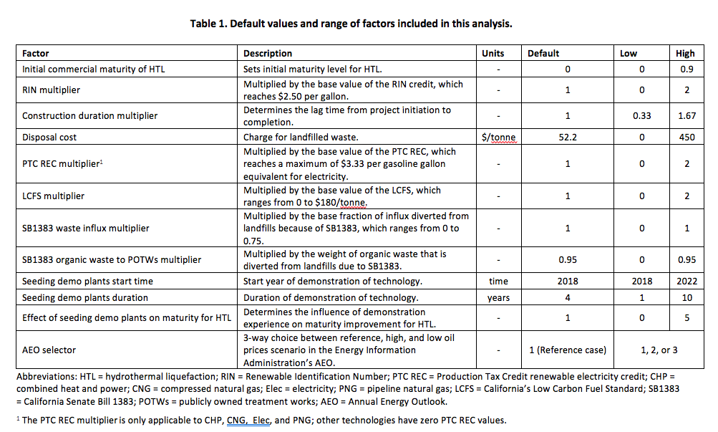

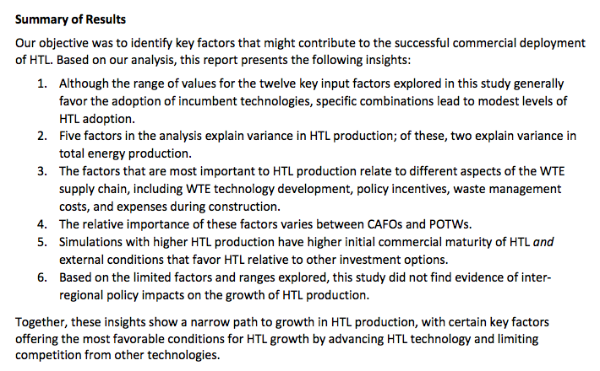

FY17 Q4 Excerpts

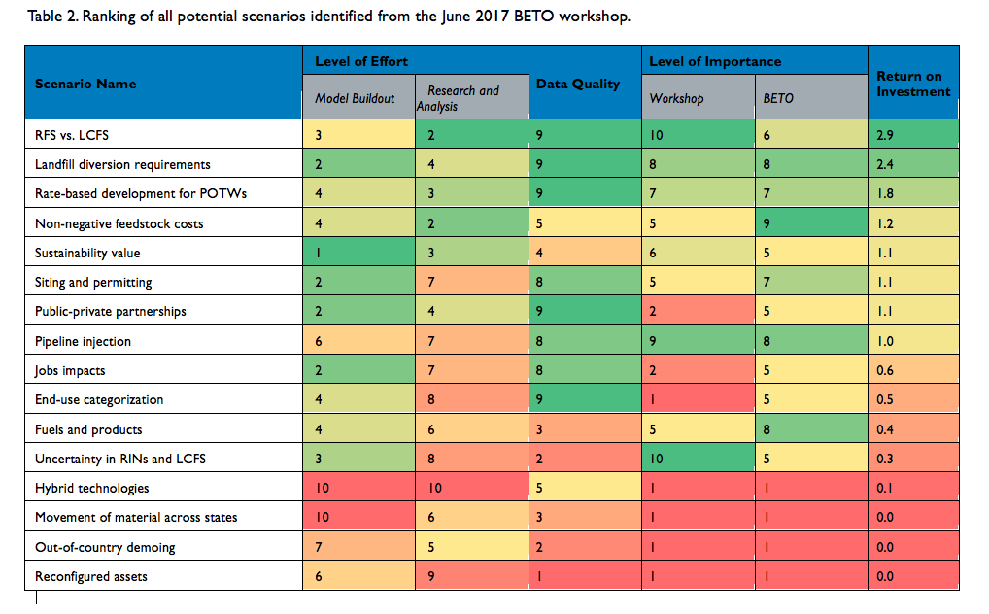

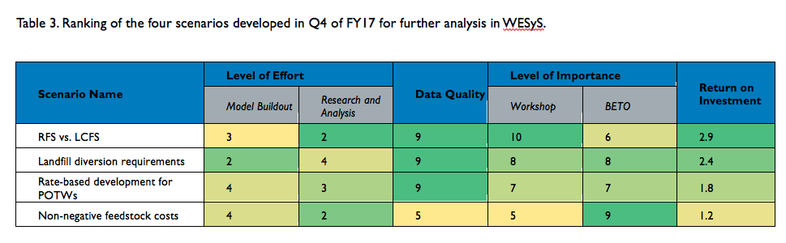

**Scenario Descriptions**

**RFS vs. LCFS:** This scenario represents biofuel production incentives from both the Renewable Fuel Standard (RFS) and the Low-Carbon Fuel Standard (LCFS). To implement this scenario, we modified the model structure to 1) accept time series data that represent the production incentives from the Renewable Identification Number (RIN) market and 2) mimic the low carbon fuel standard credit calculations. For both of these programs, the incentive is accrued at the point of production.

**Landfill diversion requirements:** For this scenario we examined California Senate Bill 1383, which sets forth a timeline for diversion of organic wastes from landfills. This scenario is only applied to the CA landfill and CA WWTP modules. For this scenario, we modified the model to perform a set of calculations that reduce the amount of organic waste (in tons per year) based on the SB 1383 timeframe – 50% by 2020, 75% by 2025 and the total amount of waste and organics that went to CA landfills in 2014. We also assumed that all waste diverted from landfills would go to wastewater treatment plants.

**Rate-based development for POTWs:** This scenario represents the ability of POTWs to take advantage of rate of return regulation to recover the cost of capital associated with the development of WTE facilities (i.e., POTWs can recover costs by increasing the rates that they charge their customers for water treatment). This scenario is only applied to the WWTP module. The rate of return that a POTW may receive on the cost of capital is determined by regulators and includes the cost of debt and the cost of equity. For this scenario, we set the expected equity fraction to zero because we assume that the facility would be able to finance everything with debt (i.e., public bond) and we modified the required rate of return to equal the debt interest rate, which we set to 3% as this is the rate for MUNI bonds. Under rate-based financing, there is a tendency to invest in the most expensive option(s). This is a well-recognized drawback of using a rate-based mechanism to cover capital investment. For example, in CA, recommendations have been made to limit rate-base increases to finance projects that directly tie into a state goal (e.g., LCFS, SB 1383) and increase demand for electricity (CPUC, 2017[1]). Because of this, in this scenario we limited the rate-based option to be available only to CA WWTPs investing in electricity generation.

**Non-negative feedstock costs:** This scenario represents a potential future reality where feedstock costs for waste become positive (i.e., there is a market for wastes). For the three types of facilities represented in WESyS (i.e., WWTPs, landfills, and CAFOs), only CAFOs are expected to have positive feedstock costs for manure in the near future. If this were to happen, CAFOs might chose to sell their waste rather than build on-site WTE facilities. For this scenario, we adopted a farmer-owned cooperative model in which farmers may sell their manure to a cooperatively owned and operated WTE facility. For these farmer-owned cooperative facilities, we have three technology pathways (Hydrothermal Liquifaction (HTL), Fischer-Tropsch (FT), and Renewable Natural Gas (RNG)) that are assumed to operate at full commercial scale. For a given technology pathway to become feasible, there must be enough animal units available to supply the commercial throughput requirement of the technology.

1. California Public Utilities Commission. 2017. Actions to Limit Utility Costs and Rates: Public Utilities Code Section 913.1 Annual Report to the Governor and Legislature. CPUC, Energy Division. May 2017. Available here: http://www.cpuc.ca.gov/uploadedFiles/CPUCWebsite/Content/About_Us/Organization/Divisions/Office_of_Governmental_Affairs/Legislation/2017/SB%20695_Master%20Draft_final_5-12-17.pdf